 |  |  |  | 
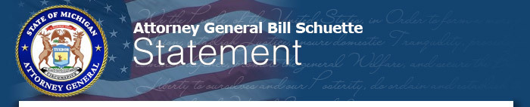
MEDIA CONTACT:
Andrea Bitely
Megan Hawthorne
517-373-8060
FOR IMMEDIATE RELEASE
October 3, 2018

Schuette Statement on Line 5 Tunnel Announcement
LANSING –Michigan Attorney General Bill Schuette today released the following statement regarding the agreement in principle for a tunnel to replace Line 5:
“Today’s tunnel announcement is an important step forward in safeguarding our Great Lakes and ensuring that Upper Peninsula residents still have access to propane to heat their homes. Creating a tunnel under the Straits means there is a timeline for shutting down the existing pipeline. This is the right path forward. I would like to thank Governor Snyder, and his team, including Assistant Attorney General Bob Reichel, for putting this agreement into place.”
Schuette first called for a tunnel to replace the existing Line 5 in August of 2017, and required Enbridge sign an agreement that banned heavy crude oil from moving through Line 5 in September of 2015. The new agreement in principle to build a tunnel includes a permanent ban on heavy crude oil.
###

